Security tools
In this section we will discuss some of the most popular tools, both open source and paid, for protecting cloud systems.
CloudGuard Dome9
It is a multifunction tool designed to secure cloud systems by analyzing the configuration in search of weaknesses, making suggestions based on the best practices for these environments, both in legal and security aspects. It also provides protection against credential theft and data loss. To do this, it uses contextual intelligence, based on the collection of information about the threats detected, their objectives, origins, and environments they attack, so that tools with greater prevention capacity are developed. It is a payment tool that can be integrated with providers such as AWS, Azure and Google Cloud.
Okta
It is a tool, also for payment, oriented to the protection of networks through the monitoring of the authentications in any device, the access control of both the users and the employees. It provides a general panel to manage their privileges and implement particular authentication policies on each device. For this, it includes a configurable login system so that it can be unique or use a double authentication factor.
Imperva Cloud Application Security
It is a payment service that protects data, applications and local or cloud systems from different providers such as AWS, Microsoft Azure and Google Cloud.
It has both security and administration measures, and is designed to help companies migrate their services to the cloud. As in the previous case, it also uses intelligence to detect and stop threats and intruders. Likewise, it facilitates the administration of all the services of a company through a single console, regardless of whether they are local or from which provider they are. Like applications, it is also capable of scaling security services based on demand.
OSSEC
It is an open source monitoring and security platform that can be used as an intrusion detection system in both on-premises and cloud environments. Due to its security techniques, it is also widely used for monitoring, firewall analysis, web servers and authentication, rootkit detection, threat protection, and real-time alerts. It is multiplatform and its administration is carried out by Atomicorp, which also offers a commercial version of the same tool.

Osquery
It is an open source tool created by Facebook in 2014, designed to analyze and monitor operating systems such as Windows, Linux, macOS, among others. It uses the FreeBSD framework to allow analyzing, through SQL queries, running processes, loaded libraries, open connections, hardware events, file hashes, among other attributes. It can be configured as a daemon to establish programmable queries and generate logs that record information about operations detected in the system. This tool can be used to detect attacks and malware as it is able to record their origin, when they have happened and their activity.
Zeek
Also known as Bro, it is software aimed at preventing and detecting intrusions through network monitoring. Unlike other similar systems, Zeek collects information about the activity and data associated with the nature of the network to adapt to the context of the same. To do this, it provides scripts in an interpretable language that can be modified to customize their behavior to the particular communication scheme. It also provides forensic services to analyze what has happened prior to an attack.
Panther
It is one of the most powerful open source tools used for the security and monitoring of cloud systems. It can be integrated through the AWS CloudFormation service. Its main characteristics are:
-Threat detection using deterministic rules that help reduce false positives.
-Analysis of system logs to identify unauthorized access and suspicious behavior according to its own threat database.
- Automatic correction of vulnerable configurations in the cloud.
Proofpoint
It is a payment tool aimed at protecting cloud services, with support for websites, email (incoming and outgoing) and social networks. It has protection against malware, phishing and identity theft. Likewise, it can also generate intelligence from the analysis of the threats detected to identify who are the possible targets. It includes attack simulation systems to provide employees with training on the techniques most used by attackers so that they can detect and act against them.
In the event of intrusions, this tool is capable of blocking attackers and malicious programs introduced both by email, websites and social networks. Similarly, you can block access to files in the cloud and verify the degree of exposure of sensitive data both in the cloud and by email.
--------------------------------------------------------------------------------------
Infection Monkey
Out of all the existing tools, we have decided to give Infection Monkey a try. It is an open source software developed by the Guardicore cloud security company, aimed at testing a cloud system carried out various attacks to verify its resistance. It can be applied to both public and private clouds.
Its origin lies in an investigation carried out by the company in 2017 on micro-segmentation applied to networks. With this methodology, a network can be divided into several subnets dedicated to a single entity, such as processes, applications, users, among others. In this way, only the strictly necessary permissions are enabled for them to carry out their tasks. However, this technique requires that the company have enough information about its network to be able to divide it, which is often an extremely complicated task to be carried out by one person. Therefore, this company developed a tool called Guardicore Centra Platform, capable of obtaining information about its infrastructure through a series of software agents and records of its information flow. It then automatically contextualizes all the data collected in order to generate a representative and detailed map of the infrastructure. It also helps define micro-segmentation policies through a simple interface based on the information collected and the vulnerability analysis it performs, suggesting measures to improve network fragmentation. This tool is valid for hybrid environments, as well as for virtual machines, containers and instances in providers such as Amazon Web Services, Microsoft Azure and Google Cloud.
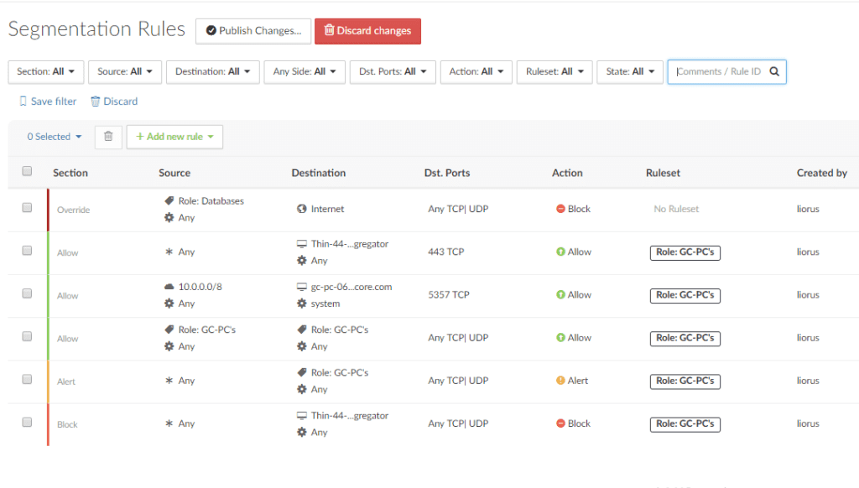

After the success of the previous tool, the Guardicore company decided to develop Infection Monkey, a new software with which to test the infrastructure of a system regardless of its components and security measures. Unlike the previous one, they decided that this would be free code, so that it could be modified according to particular needs. Essentially, it was devised as a tool to test various penetration strategies. However, the latest updates have also included the ability to review the configuration of a network, in order to look for security parameter errors in newly created networks.
It is multiplatform since it supports operating systems such as Windows and Linux, as well as those of cloud systems such as OpenStack. It is programmed in Python and can be configured to work with isolated computers or sets of systems. It should be noted that the attacks perpetrated by the tool are not simulated, but are carried out, although it then erases all traces of them to leave the machine in the same state it was in. This means that if, for example, you try to access through a user whose credentials are not secure, the tool creates a new user on the machine and then executes the attack.
Among the various characteristics it has, three in particular have caught our attention. First, Infection Monkey is designed so that its evaluations do not affect the performance of the system, so that they can be performed without slowing down the performance of your tasks.
Likewise, at the end of the tests, it generates various reports with different levels of detail, ranging from an overview of the results to a detailed record of the operations and their results. In this way, security experts can use this information to gain insight into which system components have security problems. As a third relevant quality, we highlight that for each security incident it suggests at least one solution to resolve it. In this way it identifies the problems but also helps to solve them by proposing some alternatives.
Among the different attacks that it can carry out, a set of them is based on replicating some of the most popular exploits, such as the following.
● Sambacry. It allows executing code by accessing in write mode one of the shared resources located on a Linux server. To do this, the tool uses brute force to test the connections to these resources in order to infiltrate a system.
● Shellshock. Allows attackers to execute code by appending it to the end of environment variable values. In this case, if the tool is successful, it collects information about the architecture of the machine, downloads its own file called Monkey dropper and executes.
● ElasticGroovy. With it, you can execute system commands using the Java classes of the ElasticSearch search engine. The tool examines the default ports that servers are serving queries on and tries to perform the same operations as above.
● Struts2. This vulnerability is associated with certain versions of the framework of the same name, which allows an attacker to insert commands into the system payload to perform malicious actions. Infection Monkey checks if it can exploit this vulnerability in the system and if so, infects the machine.
● Weblogic. It is a security flaw in Oracle weblogic servers, specialized in the development of business Java applications, which allows infecting machines by sending malicious packets. To test it, Infection Monkey configures a new server to send malicious data to various Oracle machines using certain commands to force its response. In case it happens, the tool spreads the infection.
● Theft of credentials. If it is a Windows system, the tool uses a customized version of the Mimikatz framework, popularly known for its ability to extract keys, pins, hashes, among others. If it is a Linux system, it generates a multitude of SSH keys and then infiltrates the system.
● Hadoop. It is a framework that allows the execution of remote tasks in distributed systems. If the tool finds such a server, it creates a task to spread the infection to all nodes in the infrastructure.
● Brute force intrusion. Infection Monkey uses the credentials stolen in previous steps to enter systems through the following protocols:
- SSH. If it manages to enter the system through SSH it collects Infrastructure and kernel information on the machine. Then download your Monkey dropper file via SFTP and run it.
- SMB (Server Message Block). It is a network protocol that allows sharing resources, such as files or external devices such as printers, between multiple Windows machines. If the tool manages to sneak in, it creates a new server to run an instance of it on the machine.
- WMI (Windows Management Instrumentation). It is an administration server to manage distributed systems remotely. When the tool infiltrates, it copies itself to other computers and spreads the infection.

In addition to the various exploits that it can apply, Infection Monkey also includes analysis tools to prevent some of the most common attacks.
Credential analysis. It applies different techniques such as analyzing the caches to obtain the keys or their hash, as well as generating passwords similar to the domain name or username to detect insecure keys. An example of this is using admin / admin as the credentials for an administrator account. To do this, it uses a customized version of the Mimikatz framework.
- Network segmentation. If the tool detects that the network is fragmented, it tries to infect the systems of a subnet and then tries to spread the infection to the rest through the channels that communicate them.
- Tunneling. Analyze segmentation rules to check the strength of communications between subnets. If the systems do not verify the origin of the messages received, they can attend to requests from malicious machines with which they establish communication to start the attacks.
While this tool has a wide range of vulnerabilities and attacks, it also has some limitations:
- Privilege escalation. It is one of the most common intrusion techniques in networks, whose objective is to infiltrate a system using a user with few permissions. The attack can then be carried out vertically, in which the attacker also grants himself root privileges through a series of kernel-level commands. While in horizontal scaling you must impersonate another user to be able to benefit from his permissions. Despite being so popular, this vulnerability is not included in Infection Monkey.
- Defense evasion techniques. It groups together a set of methods by which attackers can perform their malicious exploits without being detected by security measures. For this they can classify malicious processes as safe, hide their activity, disable security tools, among others. At the moment, the tool does not have any of the evasion techniques to test on the chosen network.
- Cyber-collection. It refers to a type of attack whose objective is to spy on entities through the inclusion of malware to collect and filter sensitive information. Although the tool is capable of gathering information about the architecture of the system, it does not include any spying technique with which to analyze the information stored in it.
- Data leakage. Today it is one of the most important security problems faced by companies. For this, a wide variety of techniques and malware can be used in order to carry out unauthorized data transmissions to attackers' systems [48]. However, Monkey Infect has not yet included the option to carry out any of the data theft strategies.

First practical application of the tool
Once we have detailed the qualities of Infection Monkey, we are going to test it experimentally. To do this, we first register on your platform to receive the download address. In addition to some personal data, we must specify the environment in which we want to install it. In our case, we are going to apply it on Azure, since we have a virtual machine in which some microservices deployed for the Cloud Computing subject of the previous semester are stored.
Una vez obtenemos el enlace de la descarga por correo, al escoger Azure como proveedor cloud nos redirige directamente a la creación de una nueva máquina virtual con la imagen de Infection Monkey, en la que podemos decidir las características de la misma, como se puede visualizar en las dos siguientes figuras. En nuestro hemos optado por la configuración básica.
------photo--------

Below in the figure we can see the specification of some fields such as the assigned resource group, the name of the machine, the region in which it is located and the base image that is that of the tool itself. To then be able to connect to it we generate a pair of SSH keys, specifying the public one as can be seen in the figure. For this we have followed the steps of the official documentation for the Ubuntu operating system.
------photo--------
Once created, we have followed this guide [50] to run the tool. First we access it through the address https: // <public IP of the MV>: 5000. A general panel appears in which, as a previous step, the purpose of the same is explained. Then with Run Monkey you can decide between running the tool inside the same machine where it is installed, simulating the propagation of an attack within the network, or choosing another system on which to simulate an intrusion. In both cases, specific values can be specified for the previously explained attacks and vulnerabilities.
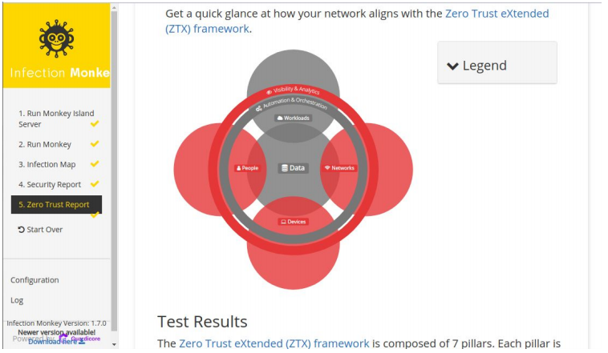
In the image you can see the analyzed entities. Those in gray color are those that could not be tested due, in our case, to the fact that we do not have tasks running on the machine or data transfers and / or use. Below are each of the incidents detected according to the category to which it belongs, as can be seen in the following two figures.
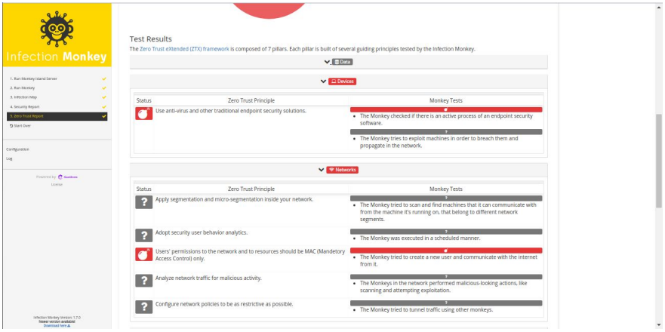
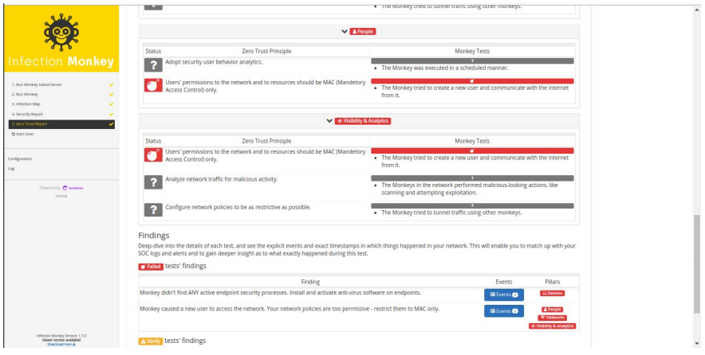
Among the different flaws it has found is the absence of antivirus or firewalls and the possibility of creating a new user with which to connect to the Internet. Likewise, it makes a record of the operations carried out and their respective results, as we explained above, in such a way that it generates a kind of detailed logs of how it has managed to carry out the attacks. Likewise, it suggests some solutions such as those shown in the figure, which in our case advise us to install some security software in addition to restricting the network access policy for users.
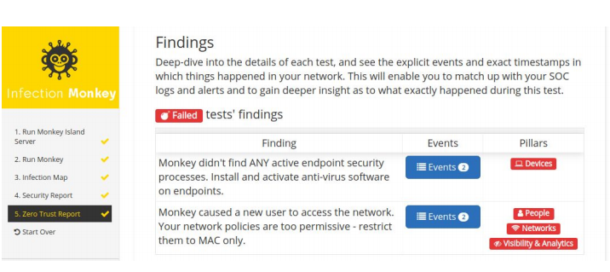

Second practical application of the tool.
Next we are going to run the tool in our own virtual machine that contains some microservices. While in the previous case the tool had access to the system to be tested since that is where it is installed, in this case it is not and therefore there are some additional steps. These include the configuration prior to downloading an instance of the tool to analyze the machine. In our case, we have included some values, such as the user of the machine to try to steal its credentials, in addition to the ports on which the two deployed microservices listen (8000 and 8001). Next, we access our machine to be tested, using SSH, to obtain a copy of the tool configured to execute it. This procedure is detailed with the necessary commands when selecting another machine to test, as can be seen in the following figure.
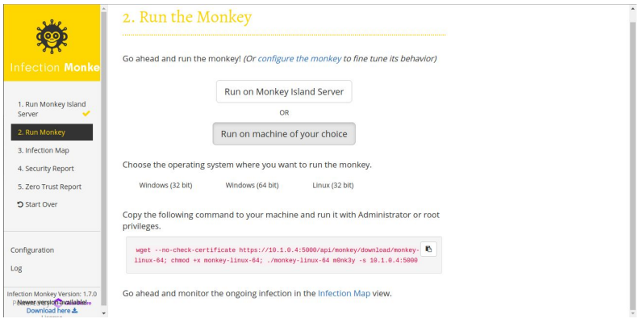
The results of this second analysis can be seen in the following two figures. The first shows the graph of the entities tested, which, as we can see, do not have as many vulnerabilities as in the previous one. In this case, the security flaw detected corresponds to the lack of an antivirus or firewall. While the rest of the categories are represented in green, which means that the attacks carried out have not been successful and, therefore, no further incidence has been found. We do not include the suggestions, since for the one found the solution is the same as before: install a security tool.
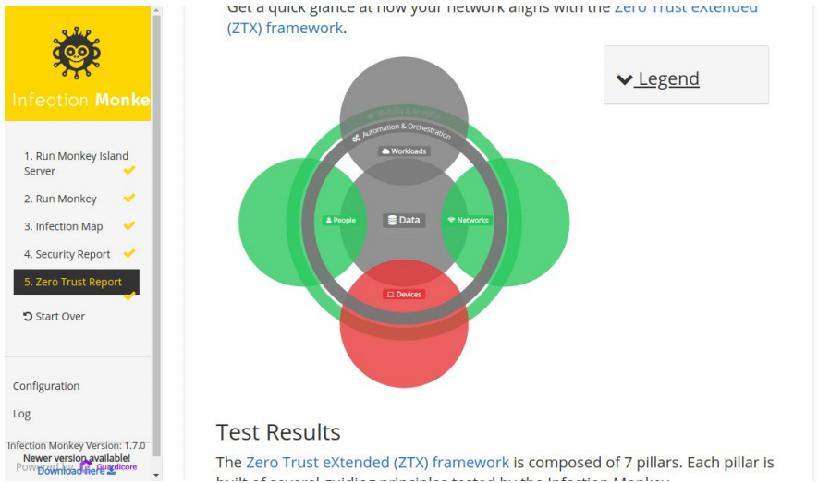
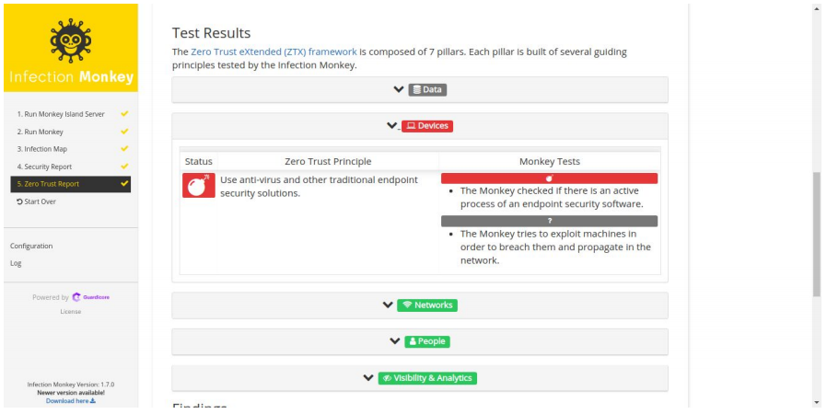

Conclusions
As a conclusion to this work, it has been seen that security is an indispensable feature in cloud environments. All companies, applications, data or in short, any type of deployment in this environment must foresee the possible problems that this type of solution entails. These incidents can come from various sources and be of various kinds. And despite relying on this type of paradigm, it must be backed up with strong security measures.
In case of not implementing enough, the consequences can be critical, from loss of valuable information to the fall of relevant services on the network. That is why supplier companies must implement as many measures as possible, updating them as their systems evolve. For this, we can include techniques for collecting and analyzing detected threats as well as the infrastructure, to generate a knowledge base that allows improving the detection capacity of security tools.
Another important aspect to take into account is that users are not exempt from responsibility and that they should also be careful with their data, in the sense that, for example, if a user does not implement sufficiently secure passwords or does not save the Due care with your personal information, the security implemented by the company does not matter, since your data or applications may be compromised.
However, as seen, there are a large number of tools available to solve or detect many of the detailed problems. It will be the supplier's responsibility to implement these tools and to keep a proper control of all the aspects that they support. A clear example has been seen in the practical example that has been developed in this work. Infection Monkey is a powerful tool for cloud environments, providing us with valuable information regarding our environment. It will be in our power to solve the problems that said tool detects in addition to using other tools such as those also commented to obtain additional information on aspects not covered by the software used.

https://www.guardicore.com/whats-new-guardicore-centra-r25/

